Methods

Participants
The participants were 303 undergraduate students from Chinese universities. Informed consent was obtained from all participants before data collection. Most of the participants came from Beijing (190). There were 215 males and 88 females in the sample and their ages ranged from 17 to 24 (mean = 18.4), with most participants being 18 years old.
The voluntary interviewees account for 10% of the total participants, with 12 individuals participating in the interviews.

Materials
An online survey was administered via WJX (www.wjx.com), an internet-based application. A detailed questionnaire was formulated to investigate a multitude of factors related to an individual’s decision to obtain a driver’s license or not, along with the motivations underlying these choices. The benefit of this approach is that it could get a comprehensive understanding of the participants' views on the matter of obtaining a driver's license.
The questionnaire was designed as a multiple-choice format, with participants selecting the option that best matched their situation. Each question had a set of predefined options, and participants could also choose to provide additional comments if they felt their situation was not fully represented by the options. The questionnaire was divided into two main sections: demographic information and reasons for obtaining or not obtaining a driver’s license. The structure of the questionnaire is illustrated in Figure 1 and described in detail below.
The primary considerations for forgoing a driver’s license were gleaned from the works by Delbosc and Currie (2013). To make the issues more adapted to the latest societal conditions, researchers added the following questions:
Underage driving restrictions (Driving is illegal until age 18 in China)
Studying in a different location without driving conditions (It is quite common to study in a different place in China)
The rise of autonomous driving as a mainstream alternative (Autonomous driving may become a reality someday)
In correspondence with this, the issues about obtaining a driving license were originally created by researchers. Please refer to the chart for specific details.

Figure 1
Illustration of the questionnaire structure
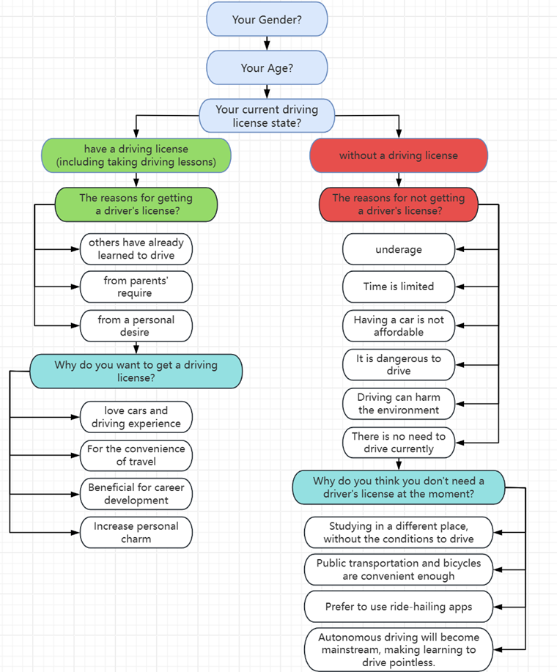
Note. An option for voluntary interviews was provided at the end of the questionnaire to gather deeper insights.
The questionnaire was designed to explore the factors influencing whether young adults in China obtain or forgo a driver’s license. It follows a logical flow, starting with demographic information and then branching into different paths based on whether participants have a driving license. The structure of the questionnaire is illustrated in Figure 1 and described below.
Section 1: Demographic Information
The questionnaire begins by collecting basic demographic information from participants:
- Gender
- Age
- Current driving license state: Participants were asked whether they currently hold a driving license, including those who have taken driving lessons but have not yet obtained a license, or those who do not have a license at all.
Section 2: Paths Based on Driving License Status
The questionnaire then branches into two distinct paths based on whether participants have a driving license:
Path 1: Participants with a Driving License
For participants who indicated that they have a driving license (or are in the process of obtaining one), the following questions were asked:
- Reasons for Obtaining a Driver’s License:
  - Others have already learned to drive
  - From parents’ requirement
  - From a personal desire
- Follow-up Question:
  - Why do you want to get a driving license?
Participants who selected “from a personal desire” were asked to provide additional details about their reasons for obtaining a license, including:
    - Love cars and driving experience
    - For the convenience of travel
    - Beneficial for career development
    - Increase personal charm
Path 2: Participants Without a Driving License
For participants who indicated that they do not have a driving license and do not plan to obtain one, the following questions were asked:
- Reasons for Not Obtaining a Driver’s License:
  - Being underage (driving is illegal until age 18 in China)
  - Having limited time
  - Being unable to afford a car
  - Considering driving dangerous
  - Believing that driving harms the environment
  - Feeling no need to drive currently
- Follow-up Question:
  - Why do you think you don’t need a driver’s license at the moment?
Participants who selected “there is no need to drive currently” were asked to provide additional details about their reasons for not needing a license, including:
    - Studying in a different place, without the conditions to drive
    - Public transportation and bicycles are convenient enough
    - Prefer to use ride-hailing apps
    - Autonomous driving will become mainstream, making learning to drive pointless
Voluntary Interviews
To obtain deeper insights into participants’ interpretations and understanding of the reasons for obtaining or not obtaining a driver’s license, voluntary interviews were arranged. The interview questions consisted of the following four questions:
- What were your reasons for obtaining or not obtaining a driver’s license? Please mention at least the two most significant aspects that have an impact on you.
- How do you choose what travel mode to take (e.g., drive, walk, public transport)?
- Will how you travel today change over the next 5, 10, or 20 years?
- Please talk about your views on the future of autonomous driving.
The last two were adapted from Delbosc and Currie (2014), who explored attitudes toward cars and licensing among young Australians using discussion forums.

Procedure
Mass online questionnaires were distributed via WeChat to students, inviting them to participate in the survey. Participants choose the option that best suited them for each question based on their actual situation, by which we could get the data on the choice of each question. After the data were collected, data analysis software (WJX) was used to analyze the proportion of participants who selected each option for each question. The discussion section of this research was based on the data collected.
Data Analysis
The data collected from the questionnaire were analyzed using WJX, which provided a breakdown of the proportion of participants who selected each option for each question. The analysis focused on identifying trends and patterns in the responses, particularly in relation to the reasons for obtaining or not obtaining a driver’s license. The results were summarized to highlight the most common reasons and their relative frequencies.
Selection of Voluntary Interviewees
Voluntary interviewees were selected from the pool of survey participants. To ensure a diverse representation of perspectives, participants were invited to volunteer for interviews based on their responses to the questionnaire. Specifically, participants who provided unique or detailed answers to the questionnaire were prioritized for the interviews. A total of 12 individuals were selected for the voluntary interviews, representing 10% of the total participants.
Conducting the Voluntary Interviews
At the same time, structured interviews were conducted with the selected voluntary interviewees. Initially, researchers posed open-ended questions to elicit general ideas. Then the interviewees were asked a few questions with prompts, and these original questions were adjusted to suit different interviewees. For example, the unlicensed participants were not asked about their motivations for obtaining a driver's license.
The respondents’ answers were recorded and categorized based on different attitudes. The responses were then evaluated to identify the most representative ones, which were used to summarize and complement the findings from the questionnaire.

